2200032991 WEEK-3 Hibernate Query Language and Native Query
We run the above project in the terminal using
mvn spring-boot:run
here we have to change and keep your mysql passcode in the application.properties files this is important
AND AFTER RUNNING YOU WILL GET THIS IMAGE IT MEANS YOUR SPRING IS RUNNING
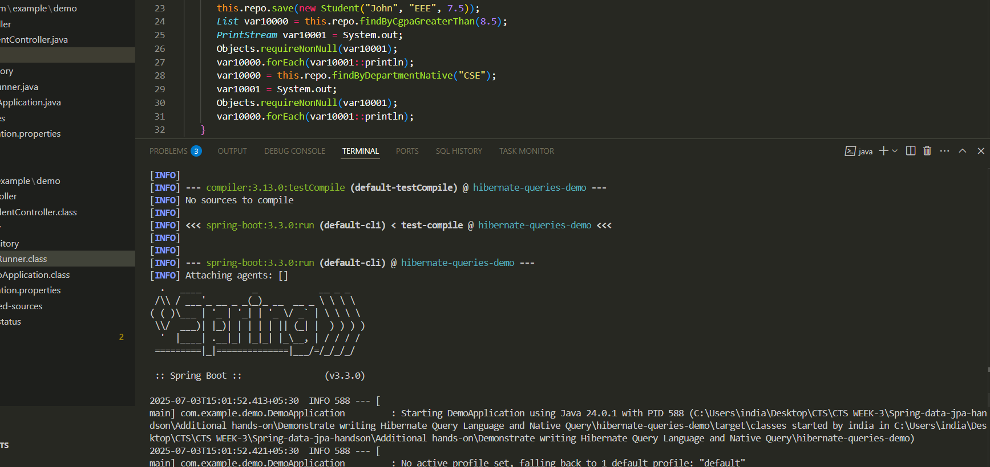
Now to see the out put you use this links
http://localhost:8080/api/students
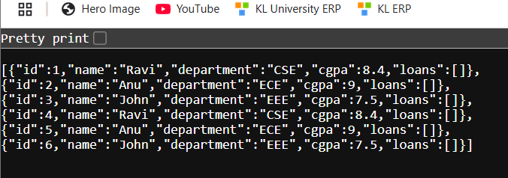

http://localhost:8080/api/students/dept/CSE
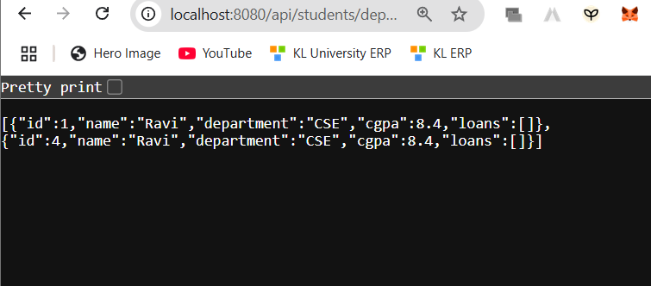
http://localhost:8080/api/students/highcgpa/8.5
